**Higher National Diploma in Information Technology**

**First Year, Second Semester Examination – 2017**

**HNDIT1212- System Analysis and Design**

**Marking Scheme**

=================================================================

**Question 01 [Total 25 Marks]**

1. Define the term information system. (03 Marks)

**It is an arrangement of Computer Technology (Hardware & Software) and Telecommunication Technology (Data, image, voice) to support and improve day to day operations, problem solving and decision making needs of management and users.**

1. List four resources in Computer Based Information System (CBIS).

**hardware**

**Software**

**Databases**

**Telecommunications**

**People**

**Procedures (Any Four) [04 Marks]**

1. Information System can be classified according to the management levels in an organization. Mention those classification levels with one example information system for each level.
2. **Three management level:**
3. **Strategic Level/Senior Management**
4. **Tactical Level/Middle Management**
5. **Operational Level/Line Management (03 marks)**

**Examples:**

1. **Strategic Level/Senior Management- Executive information system, Decision support system**
2. **Tactical Level/Middle Management- Decision support system, Management information system**
3. **Operational Level/Line Management- Transaction processing system, Office automation system (03 marks)**
4. Briefly explain “System analysis” and state four skills of system analysis.

* **A person who understands both business and computing. (03 Marks)**
* **Communication:**
* **Understanding:**
* **Teaching:**
* **Selling:**
* **Creativity:**
* **Problem solving**
* **Project management**
* **Dynamic interface (03 marks)**
* **Questioning attitude and inquiring mind**

1. **L**egacy systems are potentially **problematic**. Do you agree? Justify your answer?

**Yes/ I Agree ( 02 marks)**

**Reason: Legacy systems has some problems.**

**Such as**

* **Often run on obsolete hardware**
* **Spare parts for such computers become increasingly difficult to obtain**
* **Hard to maintain, improve, upgrade and expand**
* **Lack of Flexibility.**
* **Lack of Information.**
* **Lack of IT Resources & Dependency on Individuals.**
* **Costly to Support & Maintain.**
* **High Complexity.**

(04 Marks)

**------------------------------------------------------------------------------Total 25 Marks-------------------------**

Q2

1. Describe the waterfall model of software development. (03 Marks)

It is a linear sequential model. It has Separate and distinct phases of specification and development

1. State two strengths and two weakness of waterfall model. (04 Marks)

Strengths: (any two answer 02 marks)

* Easy to understand, easy to use
* Provides structure to inexperienced staff
* Milestones are well understood
* Sets requirements stability
* Good for management control (plan, staff, track)
* Works well when quality is more important than cost or schedule

Weakness: (any two answer 02 marks)

* It has a rigid design
* Inflexible
* It has a top-down procedure
* One phase must be completed before the next phase starts
* No phase can be repeated
* Time consuming

1. In which situation do you use Prototype software development model? And state two types of prototype models. (03 Marks)
2. It is very difficult for end-users to anticipate how they will use new software systems to support their work. If the system is large and complex, it is probably impossible to make this assessment before the system is built and put into use.

* Throw-away Prototyping
* Evolutionary Prototyping (03 marks)

1. How does the agile model overcome the limitations of the waterfall model?

Waterfall model is fully plan-driven process. It has several limitations such as

* Cannot accommodate changing requirements.
* It is difficult to measure progress within stages.
* Time and Resource wasting (one group of workers should wait for the previous stage output)
* Poor model for long and ongoing projects.

But agile model of software development are iterative approaches where the software is developed and delivered to customers in increments. Unlike plan-driven approaches, the functionality of these increments is not planned in advance but is decided during the development.

* Agile modelrequiring frequent communication, development, testing, and delivery.
* Agile development focuses on rapid development and frequent user contact to create software that is highly relevant to business users.
* This software does not have to include every possible feature the user will require. Rather, it must meet only the basic requirements.

**(Any three reasons) [06 Marks]**

1. Read the following scenario and select suitable software life cycle model and justify your answer. (06 Marks)

Suitable model is Spiral model.

Working on the aircraft is the real time example of a spiral model. The risk associated and cumulative costs both are the very important aspect of the aircraft systems.

Justification:

1. Understanding the basic requirements, need and goal is the first step of the spiral model.
2. Estimate the schedule, time, cost and the various resources to make the components or the part of an aircraft is comes under the category of planning which is the second iteration of spiral model.
3. Identifying, estimating, and monitoring various risks associated covered under risk association.
4. Developing the final model based upon the approved requirements is the developing iteration of the spiral model which is called Engineering which Includes requirement gathering and design of the software system.
5. Includes coding and testing and launch of a aircraft traffic system is the most crucial iteration of spiral model which is called Construction and release Last iteration is the Evaluation, feedback or the limitation or the success story of launching of the air trafﬁc control (ATC) system for airport

**(Model -02 Marks, Justification- 04 Marks)**

**------------------------------------------------------------------------------Total 25 Marks-------------------------**

Q3

1. Explain the term Requirements elicitation. (03 Marks)

Requirements elicitation is the process of identifying the sources of requirements for a new system and obtaining those requirements from those sources.

1. Explain the difference between functional requirements and non-functional requirements (02+02 Marks)

|  |  |
| --- | --- |
| **Functional Requirements** | **Non-functional requirements** |
| Specify what the information system must do  /or  Functionality or services that the system is expected to provide. | Specify a property / quality the system must have or/  These are constraints on the services or functions offered by the system. |

1. **Functional requirements:**

Any services from system can accept as answer

Example: The system operator monitor child’s activities

The system operator maintain the records about those activities

Analyse about the child behaviour

Generate daily reports **(Any three)**

**Non-functional requirements:**

**Any two examples from these following requirements**

Performance requirements

Reliability

Portability

Interface requirements

Interoperability requirements

Ethical requirements

Safety requirements

Delivery requirements

Implementation requirements  **[03 + 03Marks]**

1. What do you understand by “Feasibility study”? Why do you need to do the Economic Feasibility? (02 Marks)

* The measure of how beneficial an information system will be to an organization.
* It is a measure of **the cost-effectiveness of a project. (02 marks)** 
  + Is the solution cost-effective?
  + How profitable the solution is?

1. KSNTG Pvt Ltd expects to undertake a project for their business. They received project (project R, project T) proposals from two different companies. Assume the following cash flows for two projects.

|  |  |  |
| --- | --- | --- |
| Year | Project R | Project T |
| 0 | Rs. -100 000 | Rs.-100 000 |
| 1 | Rs.50 000 | Rs.10 000 |
| 2 | Rs.40 000 | Rs.30 000 |
| 3 | Rs.30 000 | Rs.40 000 |
| 4 | Rs.10 000 | Rs.60 000 |

* 1. Which is the best project to accept according to payback method? Justify your answer?

(01 Marks)

* 1. **For the Project R**

|  |  |  |  |  |
| --- | --- | --- | --- | --- |
| Year | Cash inflow | Cash outflow | Net of cash | Cumulative cash flow |
| 0 |  | Rs.-100 000 | Rs.-100 000 | Rs.-100 000 |
| 1 | Rs.50 000 | 0 | Rs.50 000 | Rs.-50 000 |
| 2 | Rs.40 000 | 0 | Rs.40 000 | Rs.-10 000 |
| 3 | Rs.30 000 | 0 | Rs.30 000 | Rs.20 000 |
| 4 | Rs.10 000 | 0 | Rs.10 000 | Rs.30 000 |

Pay Back Period = 2 + (10 000/30 000) X12

= 2years and 4 months (02 Marks)

For the Project T (01 marks)

|  |  |  |  |  |
| --- | --- | --- | --- | --- |
| Year | Cash inflow | Cash outflow | Net of cash | Cumulative cash flow |
| 0 |  | Rs.-100 000 | Rs.-100 000 | Rs.-100 000 |
| 1 | Rs.10 000 | 0 | Rs.10 000 | Rs.-90 000 |
| 2 | Rs.30 000 | 0 | Rs.30 000 | Rs.-60 000 |
| 3 | Rs.40 000 | 0 | Rs.40 000 | Rs.-20 000 |
| 4 | Rs.60 000 | 0 | Rs.60 000 | Rs.40 000 |

Pay Back Period = 3 + (20 000/60 000) x12

= 3years and 4 months (02 Marks)

**Project R should be accept**. Because it has shorter Pay Back Period (2years 4 months).

**(02 Marks)**

**------------------------------------------------------------------------------Total 25 Marks-------------------------**

**Question 04 [Total 25 Marks]**

1. List major component of software development. (03+02 Marks)

* Methodology- A very **formal** and **accurate** system development process that defines a set of Activities ,Methods ,Best practices, Deliverables, Automated tools
* Modelling Methods or Techniques-A set of **techniques** used to implement a Methodology. DFD,ER
* Tools-Tools are Software systems and they **assist** analysts and designers to build information systems. -Easy Case, Rational Rose

1. Young inventors club decided to implement new web site to motivate their members. They carryout various activities that aid the members to make their dreams a reality.

Web site contains the following information:

* + People who have sufficient qualifications are asked to apply by completing and submitting the application form. Member details are stored in ‘member file’.
  + The Accounts department using information from the member file decides the membership fee and sends invoice to the relevant member. Membership Payments made are registered on the ‘payment file’.
  + Administrator can schedule activities for the members but members who have paid the fees can participate in those activities. ‘Schedule file’ maintains all the scheduled details.
  + System maintains all the publications in ‘publication file’ and Members can view the publications.
  1. Draw the context diagram for the above young Inventors’ system? (08 Marks)
  2. Draw the level 0 Data Flow Diagram (DFD) for above system? (12 Marks)

This is only sample

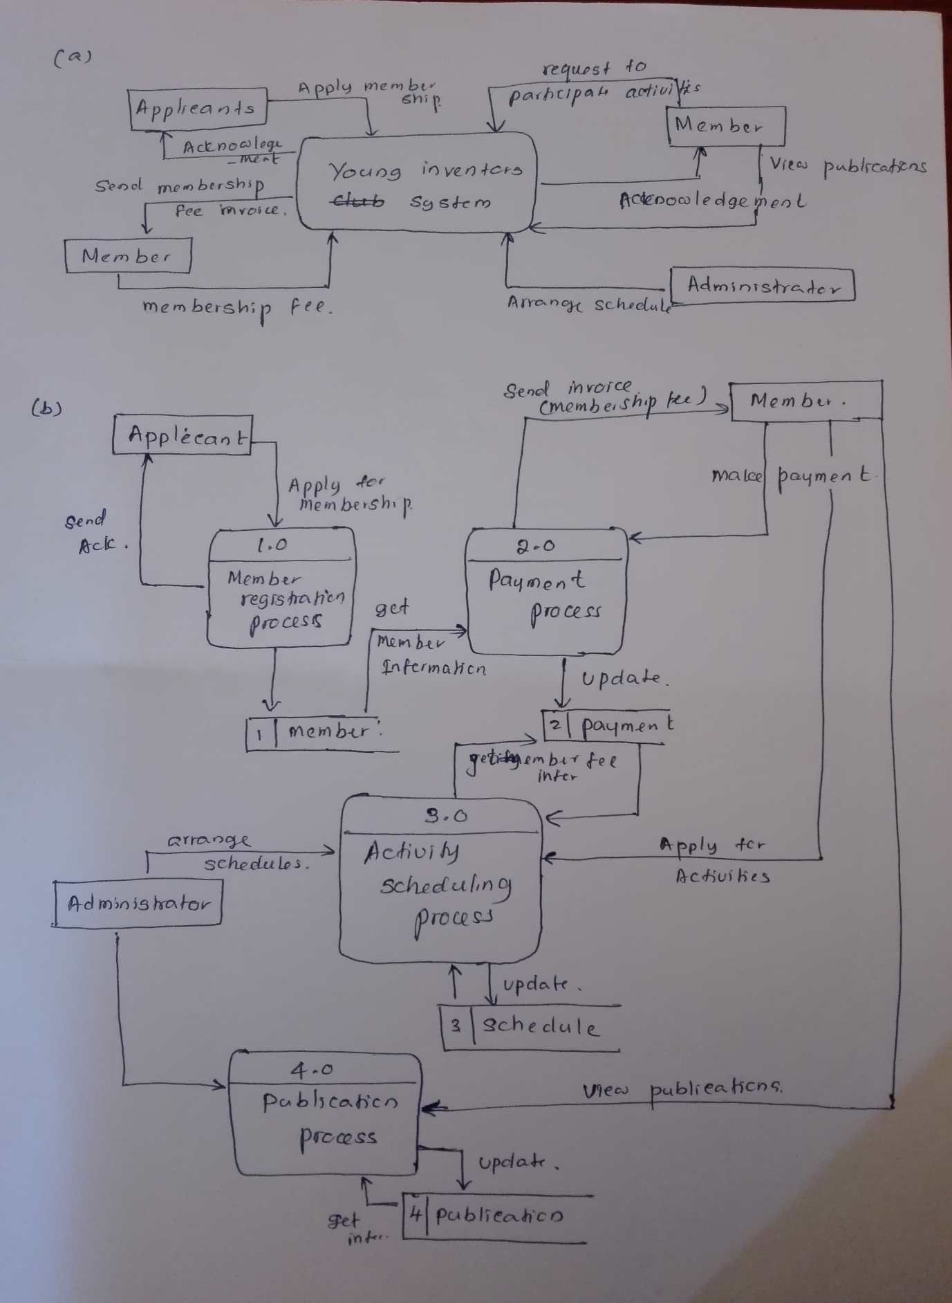

**------------------------------------------------------------------------Total 25 Marks-------------------------**

**Question 05 [Total 25 Marks]**

1. State three limitations of software testing. (03 Marks)

* Poor testing process
* Inadequate time
* Future requirements not anticipated
* Inadequate test data
* Software changes inadequately test

1. What is CAST tools? Mention its two functions.

Automated testing tools - **Computer Aided Software Testing** (CAST) tools (02 marks)

* control the execution of tests (02 marks for any two)
* the comparison of actual outcomes to predicted outcomes
* the setting up of test preconditions
* Test reporting functions.

1. Testing is a part of broader process of system development life cycle. Describe the following terms. (02x3 Marks)
   1. Black-Box Testing - **Black Box testing** takes an external perspective of the test object to derive test cases.
   2. White-Box Testing - **White box testing** uses an internal perspective of the system to design test cases based on internal structure.
   3. Integration testing - **Integration** is the phase in software testing in which individual software modules are combined and tested as a group.
   4. The purpose of integration testing is to verify **functional, performance, and reliability requirements** placed on major design items.
2. Briefly explain bespoke package with two advantages and two disadvantages.

Programmers write an application to meet the specific needs of the organization.

It is involves all the tasks included in the software development and testing cycle

(02 marks)

Advantages (02 marks)

* The software should meet the organization's specific needed.
* Competitive advantage
* It can make modification for future needs

Disadvantages: (02 marks)

* + It make risk
  + Greater chance of bugs
  + Waste time and cost

1. At the end of system implementation, file conversion can be done in different ways. Briefly explain the pilot operation method with two advantages and two disadvantages.

The pilot operation involves selecting part or parts of an organization to operate running the new system in parallel with the existing system. When the branch or department piloting the system is satisfied with the new system, they cease to use the old system. The new system is then piloted in another area of the organization.

(02 marks)

|  |  |
| --- | --- |
| **Advantages** | **Disadvantages** |
| Less risky than direct changeover  Less costly than complete parallel running | Can take a long time to achieve Total changeover  Not as safe as complete parallel running |

(02x2 marks)

**------------------------------------------------------------------------------Total 25 Marks-------------------------**